**Monitoring health check status**

1. Installed Prometheus in the EC2 instance and launched it with port number 9090

Prometheus url : **http://18.141.168.142:9090/**

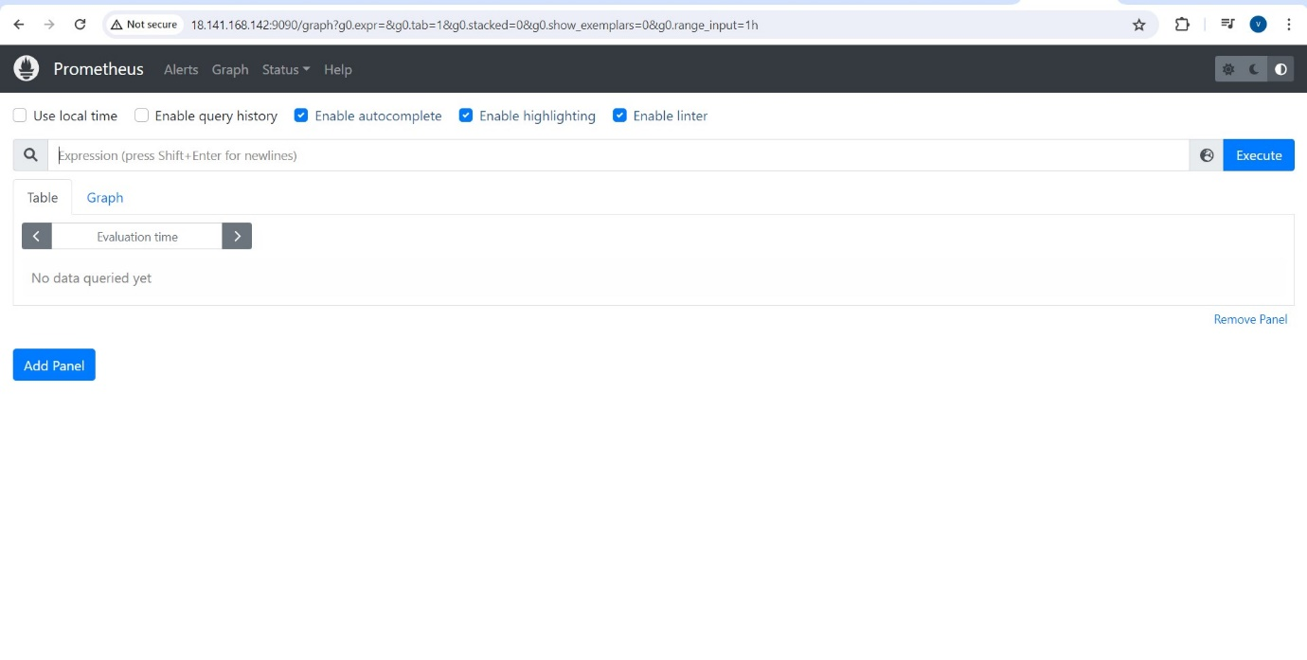

1. Installed Grafana in EC2 instance and launched it with port number 3000

Grafana url : [**http://18.141.168.142:3000/**](http://18.141.168.142:3000/)

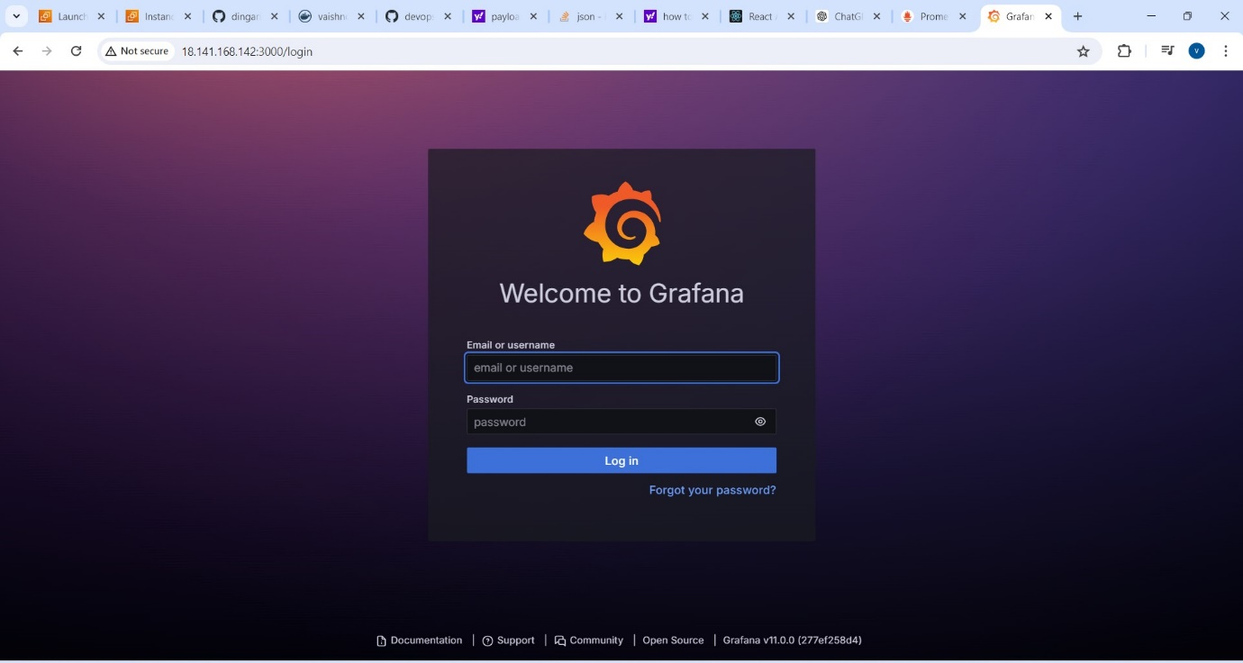

1. Added Prometheus as the data source in Grafana

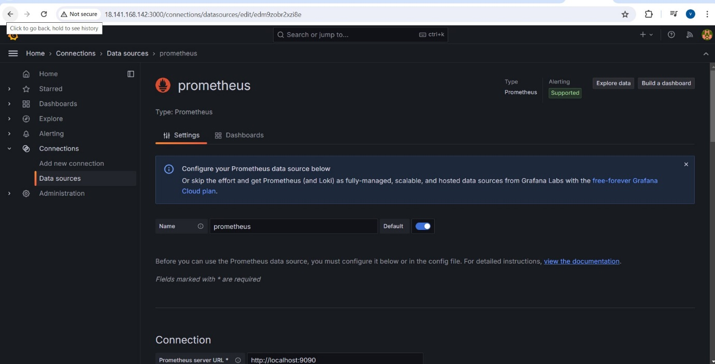

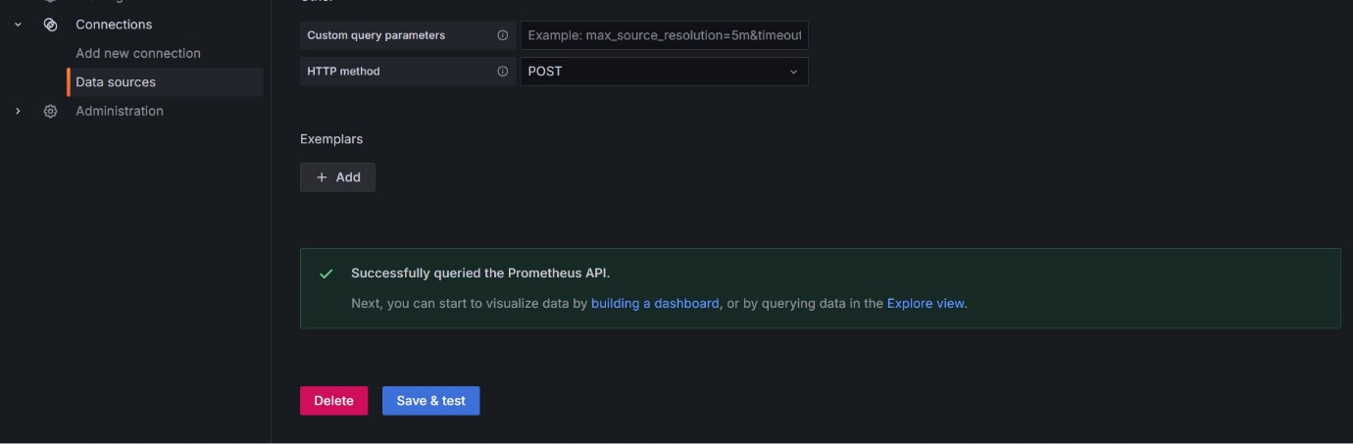

1. Created alert rules

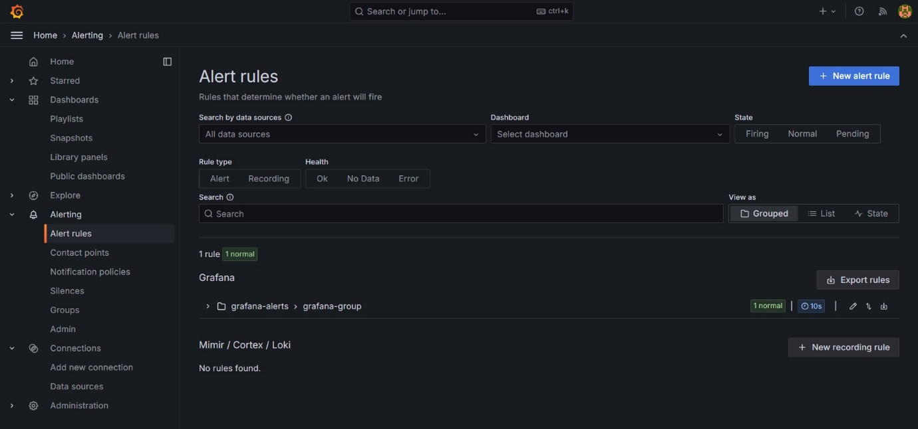

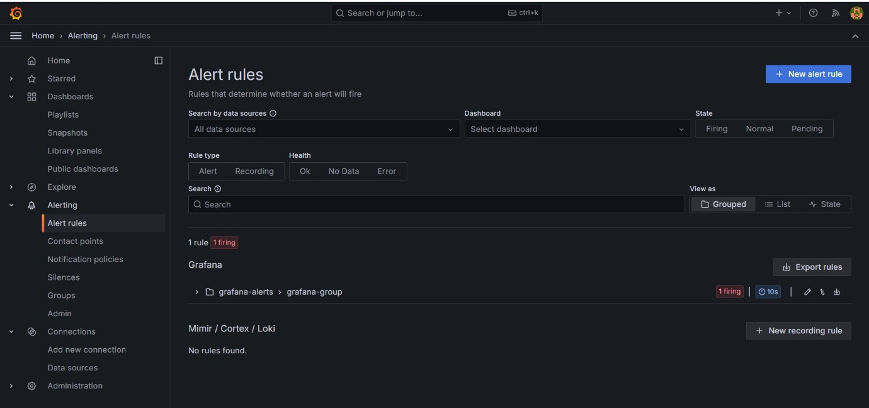

1. Created contact points to notify the alert instance failure

